

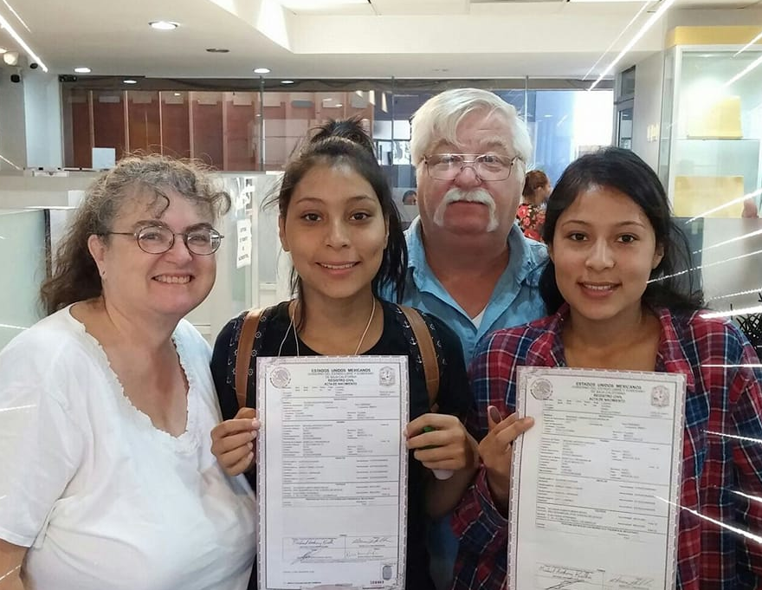

From the Kuelker’s in Mexico
Mike, Becky, Berenice and Selena
And all around the USA as well
Michael Jr, Brittany, Melissa, Christopher, Christine, Christian, Melinda, Dennis, Nathan and Alex

From the Kuelker’s in Mexico
Mike, Becky, Berenice and Selena
And all around the USA as well
Michael Jr, Brittany, Melissa, Christopher, Christine, Christian, Melinda, Dennis, Nathan and Alex

